Instructions

1. Download and install anaconda3 from given link

- link : <https://www.filehorse.com/download-anaconda-64/download/>

- At the stage given in the image below check both checkboxes

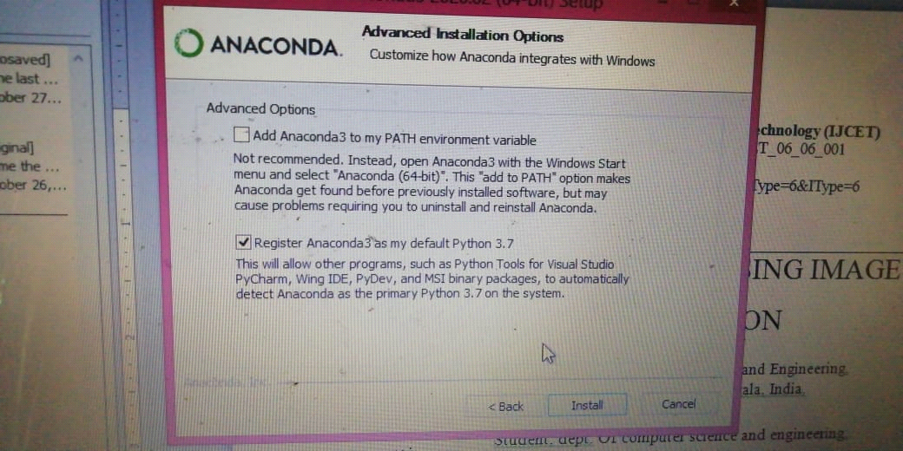

1. Extract the ‘ml_env’ folder and paste it to the anaconda3’s **envs** folder
2. Extract the ‘Runway_Fullcode’ folder
3. Open anaconda prompt
4. In prompt(cd) Navigate to ‘Runway_Fullcode’ folder
5. Run command : activate ml_env
6. Run command : python gui.py